Mission Rome
- Jubilee 2014 -
On Saturday, October 25th we will gather as International Schoenstatt Youth to carry out a “Rome Mission”. After the Audience with Pope Francis we will head to the “Santi Patroni d´Italia” Parish to beginn our mission.
There is a €12.00 registration fee to cover meals expenses (lunch and supper).
Please complete this registration form.
Group responsible:
Name:
If the group responsible is not a Father or a Sister, please give the name of your Youth advisor.
………………………………………………..
Country:
City:
Age:
e-mail:
Telephone:

Group
Number of participants:

Observations:
Please, let us know if one or more members of your group has any health condition (celiac, allergic, any other health problem).

Name | Last name | Indication
Form of payment:
Payment can be done in cash during the Jubilee celebrations or immediately after the Audience with the Holy Father or by a wire transfer.

Cash
Wire transfer
Important: Specify the transfer as “CONTRIBUTION” not as “payment”.
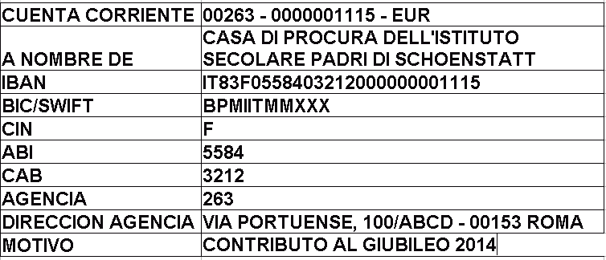

For more information please contact:
Ester Forcada: ester_fz@hotmail.com
Matías Rossi: matiasgarossi@hotmail.com
Deilton de Sousa: decoelhosbc@gmail.com

